In Life and in Death We Belong to God…
________________________________________________________________

In life and in death we belong to God.

This fundamental affirmation of our faith shapes our approach to ministry at the time of death. We are God’s people, and nothing-not even death-can separate us from God’s love. In the face of death, we affirm with tears and joy the hope of the gospel and the promise of life through the resurrection of Jesus Christ. We do so as a community of faith, supporting one another through our prayers and our expressions of love, compassion, and sympathy.

What is the purpose of the Memorial Garden?

The Memorial Garden is a dignified final resting place for the ashes of members of Covenant Presbyterian Church and of persons who had or have been closely connected had to this church.

Who may have ashes interred in the garden?

Anyone who is or has been connected with Covenant Presbyterian Church as determined by the pastor and/or the Memorial Garden Committee is eligible to have his or her ashes interred.

How will ashes be interred?

Ashes will be spread in the garden, but no containers may be used. Ashes will not be placed in reserved locations in the garden and personal objects such as flowers, flags, or photographs may not be placed in the garden.

How will the deceased be memorialized?

For those who are or have been closely connected with Covenant Presbyterian Church, a small plaque intended to memorialize the deceased and bearing the deceased’s name and years of birth and death may be mounted on the garden wall that faces the church. Plaques will be placed in chronological order based on date of death.

Will records be kept of those persons whose ashes are interred?

Yes. A registry containing appropriate biographical information will be maintained in the church office. In addition, an electronic record will be stored offsite.

What costs are associated with interment of ashes?

As part of the church’s ministry at the time of death, no fee will be charged for the interment, for the plaque or for the inscription and mounting of the plaque. Gifts to the church are welcome and may be made payable to Covenant Presbyterian Church and may be designated to the Endowment Fund, the Pastor’s Discretionary Fund, or the General Fund of the Church.

Will there be a service of any kind associated with the interment?

Yes. There may be a service in consultation with the pastor, if the family so desires.

Based upon Guideline adopted 10/20/13; revisions adopted 10/20/19

Covenant Presbyterian Church
2001 North Coalter Street
(540) 885-2138
www.covenantpresstaunton.org
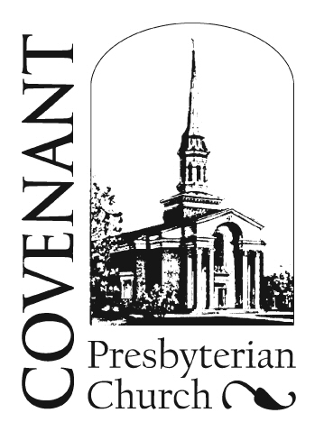

Memorial Garden

