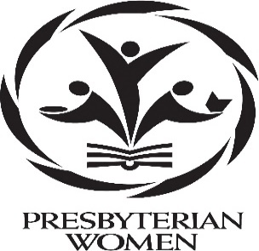**PRESBYTERIAN WOMEN 2024 – 2025**

Moderator: Frances Craig

Co-Moderator: Mary Ann Stripling

Secretary: Nancy Headifen

Treasurer: Linda Foster

Circle Leader: June Shipplett

2024-2025 ***PW/Horizons*** Bible Study: ***Let Justice Roll Down: God’s Call to Care for Neighbors and All Creation*** by Patricia Tull

***Who We Are:***

Every Covenant Presbyterian Church woman is a member of the Presbyterian Women.

***The Presbyterian Women Purpose:***

Forgiven and freed by God in Jesus Christ, and empowered by the Holy Spirit, we commit ourselves:

to nurture our faith through prayer and Bible study,

to support the mission of the church worldwide,

to work for justice and peace, and

to build an inclusive, caring community of women that strengthens the Presbyterian Church (U.S.A.) and witnesses to the promise of God's kingdom.

***Our Present:***

At Covenant, PW meets monthly for Bible study, fellowship, and service projects. Additionally, Covenant Church women meet monthly for study, fellowship and needlework at *Novels and Needles*.

Over the years, PW has supported food pantries, shelters for battered women, retirement homes, and Valley Mission. We financially assist other missions, both national and worldwide.

Our calendar year begins in September when new officers are installed, and our study book is introduced. Special events celebrate the Thank Offering and the Birthday Offering each year in support of churchwide missions. PW engages the whole Covenant Family in the CWS Blanket Offering, a benevolence that buys blankets for people who have experienced disasters in their lives.

The women of the Shenandoah Presbytery gather annually at Massanetta Springs Camp and Conference Center for study, worship and nurturing and officers are installed.

***Our Past:***

***1959:*** Covenant Presbyterian Church was founded as a member of the Lexington Presbytery, and we were known as the Women of the Church.

***1974:*** A new Presbytery was created from the Lexington and Winchester Presbyteries and was named the Shenandoah Presbytery. At that time, we were one of 108 organized churches in the new Presbytery and the Women of the Church were serving as elders, deacons, teachers, leaders, and committee members on all levels.

***1976:*** Dr. Martha Grafton of Staunton became the first woman, and the second layperson elected as Moderator of the Shenandoah Presbytery. Mrs. Ollie Brand served as the first President of the Women of the Church in Covenant Church.

***1987:*** A merger combined the structure of Women of the Church (PCUS) with those of the United Presbyterian Women (UPCUS).

***1988:*** Presbyterian Women (PW) of the Shenandoah Presbytery, Synod of the Mid-Atlantic of the Presbyterian Church U.S.A was inaugurated at Massanetta Springs.